**Assignment NO6**

**TASK 1 (1):**

**Code: output:** #include<iostream>

using namespace std;

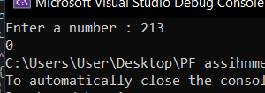bool isperfect(int number)

{

int num2, count;

int perfectnumber;

perfectnumber = 0;

count = 1;

while (count < number)

{

num2 = number % count;

if (num2 == 0)

{

perfectnumber = perfectnumber + count;

}

count++;

}

if (perfectnumber == number)

return true;

else

return false;

}

int main()

{

int num;

cout << "Enter a number : ";

cin >> num;

cout<<isperfect(num);

}

**TASK 1 (2):**

**Code: output:**

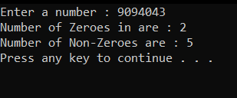#include<iostream>

using namespace std;

int zeroes = 0;

int nonzeros = 0;

int function(int number)

{

int num1;

while (number > 0)

{

num1 = number % 10;

if (num1 == 0)

{

zeroes++;

}

if (num1 != 0)

{

nonzeros++;

}

number = number / 10;

}

return 0;

}

int main()

{

int num;

cout << "Enter a number : ";

cin >> num;

function(num);

cout <<"Number of Zeroes in are : " << zeroes << endl;

cout << "Number of Non-Zeroes are : " << nonzeros << endl;

system("pause");

return 0;

}

**TASK 1 (3):**

**CODE:**

#include<iostream>

using namespace std;

int upper = 0, lowercase = 0, SpecialCharacters = 0, digit = 0;

char arr[4];

int function(char arr1[4])

{

for (int i = 0; i < 4; i++)

{

if (arr1[i] >= 65 && arr1[i] <= 90)

{

upper++;

}

if (arr1[i] >= 97 && arr1[i] <= 122)

{

lowercase++;

}

if ((arr1[i] >= 33 && arr1[i] <= 47) || (arr1[i] >= 91 && arr1[i] <= 96))

{

SpecialCharacters++;

}

if(arr1[i]>=48 && arr1[i]<=57)

{

digit++;

}

}

}

int main()

{

char arr[4];

cout << "Enter password : ";

for (int i = 0; i < 4; i++)

{

cin >> arr[i];

}

function(arr);

if (digit == 1 && SpecialCharacters == 1 && lowercase == 1 && upper == 1)

cout << "Your Entered password is strong";

else

{

cout << "password is not strong";

}

system("pause");

return 0;

}

**OUTPUT:**

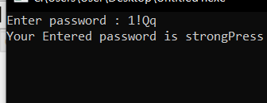

**TASK 2:**

**CODE:**

#include<iostream>

using namespace std;

int num1 = 0, num2 = 0, num3, sum, sum2,sum3, number = 0, number1 = 0;

int add(int a, int b)

{

cout << "Function1: I have been called " << a << " times" << endl;

cout << "sum is :" << b << endl;

return 0;

}

int add1(int c, int d)

{

cout << endl << "\nFunction2: I have been called " << c << " times" << endl;

cout << "sum is :" << d << endl;

return 0;

}

int main()

{

int num4, num5;

cout << "Enter 1st number : ";

cin >> num4;

cout << "Enter 2nd number : ";

cin >> num5;

sum = num4 + num5;

sum2 = sum;

do {

cout << "Enter a number : ";

cin >> num3;

if (num3 != -1)

{

number++;

number1++;

}

else

{

add(number,sum);

}

} while (num3 != -1);

cout << "Enter 1st number : ";

cin >> num4;

cout << "Enter 2nd number : ";

cin >> num5;

sum = num4+num5;

number = 0;

do {

cout << "Enter a number : ";

cin >> num3;

if (num3 != -1)

{

number++;

number1++;

}

else

{

add1(number, sum);

}

} while (num3 != -1);

}

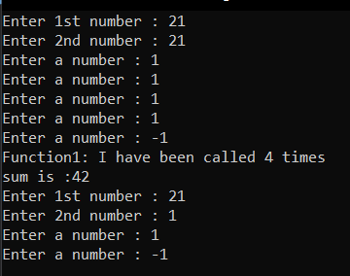**OUTPUT:**

**TASK 7:**

**Code: output:**

#include<iostream>

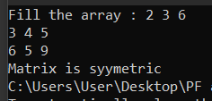using namespace std;

int num = 0;

void function(int arr[][3])

{

cout << "Fill the array : ";

for (int i = 0; i < 3; i++)

{

for (int j = 0; j < 3; j++)

{

cin >> arr[i][j];

}

}

}

void function2(int arr[][3])

{

int arr1[3][3];

for (int i = 0; i < 3; i++)

{

for (int j = 0; j < 3; j++)

{

arr1[i][j] = arr[j][i];

}

}

for (int i = 0; i < 3; i++)

{

for (int j = 0; j < 3; j++)

{

if (arr1[i][j] != arr[i][j])

{

num++;

}

}

}

}

int main()

{

int arr2[3][3];

function(arr2);

function2(arr2);

if (num >= 1)

{

cout << "Matrix is not syymetric ";

}

if (num == 0)

{

cout << "Matrix is syymetric";

}

return 0;

}

**TASK 9:**

**Code:**

#include<iostream>

using namespace std;

int* pointer[10];

void function(int arr[10])

{

cout << "Enter the numbers in the array : ";

for (int i = 0; i < 10; i++)

{

cin >> arr[i];

}

}

void function2(int arr[10],int number)

{

for (int i = 10 - number,j=0; i < 10 ; i++,j++)

{

pointer[j] = &(arr[i]);

}

int j = 0;

for (int i = number ; i < 10; i++,j++)

{

pointer[i] = &(arr[j]);

}

cout << "Shifted array is : ";

for (int i = 0; i < 10; i++)

{

cout << *pointer[i] << " ";

}

}

int main()

{

int arr1[10];

int num;

cout << "ENter a number : ";

cin >> num;

function(arr1);

function2(arr1, num);

system("pause");

return 0;

}

**OUTPUT:**

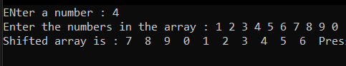

**TASK 5:**

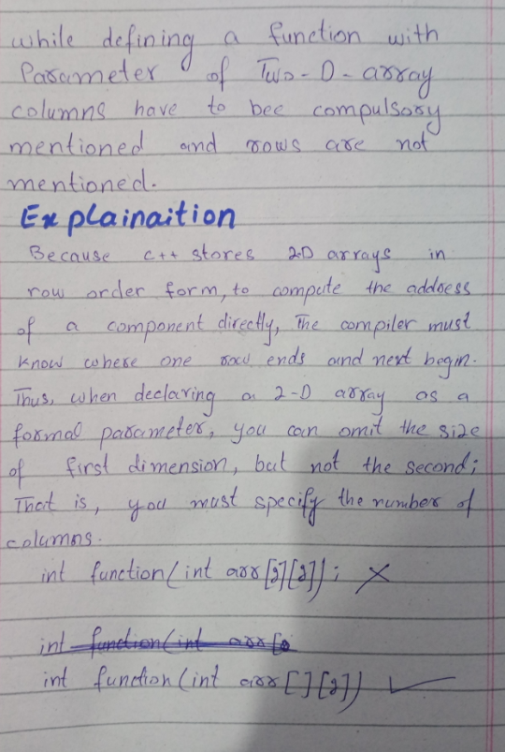

**TASK 3:**

**CODE: OUTPUT:**

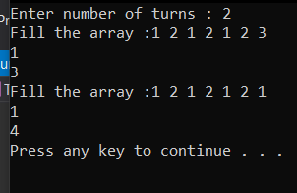#include<iostream>

using namespace std;

void function(int arr[7])

{

cout << "Fill the array :";

for (int i = 0; i < 7; i++)

{

cin >> arr[i];

}

}

void function2(int arr[7])

{

int* pointer[7];

int arr1[7];

for (int i = 0; i < 7; i++)

{

int num = 0;

pointer[i] = &(arr[i]);

for (int j = 0; j < 7; j++)

{

if (*pointer[i] == arr[j])

{

num++;

}

}arr1[i] = num;

}

int num2 = arr1[0];

int num3 = *pointer[0];

for (int i = 1; i < 7; i++)

{

if (arr1[i] > num2)

{

num3 = *pointer[i];

num2 = arr1[i];

}

}

cout << num3 << endl;

cout << num2 << endl;

}

int main()

{

int turns;

cout << "Enter number of turns : ";

cin >> turns;

int arr1[7];

while (turns > 0)

{

function(arr1);

function2(arr1);

turns--;

}

system("pause");

return 0;

}

**Question 6**

#include<iostream>

using namespace std;

int same(int array[], int size)

{

for (int s = 0; s < size; s++)

{

cout << array[s] << " ";

}

int *x = array;

int* p = &array[4];

int t = 0;

for (int a = 0; a < 5; a++)

{

if (array[a] == *p)

{

p--;

t++;

}

}

if (t == 5)

cout << "\narray is same";

else

cout << "\narray is different";

return 0;

}

int main()

{

int array[5];

int size = 5;

for (int a = 0; a < size; a++)

{

cin >> array[a];

}

same(array, size);

cout << endl;

system("pause");

return 0;

}

**Output**

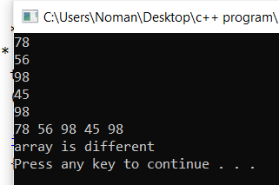

**Question #4**

#include<iostream>

using namespace std;

float sum1 = 0, sum2 = 0;

void getData(int arr[][3], int arr1[][3])

{

cout << "Enter lowest temperature of months : " << endl;

int number = 1;

for (int i = 0; i < 4; i++)

{

for (int j = 0; j < 3; j++)

{

cout << "Enter data for " << number << "th month :";

cin >> arr[i][j];

number++;

}

}

cout << "Enter heighst temperature of months : " << endl;

int number1 = 1;

for (int i = 0; i < 4; i++)

{

for (int j = 0; j < 3; j++)

{

cout << "Enter data for " << number1 << "th month :";

cin >> arr1[i][j];

number1++;

}

}

}

void avg_High(int arr1[][3])

{

for (int i = 0; i < 4; i++)

{

for (int j = 0; j < 3; j++)

{

sum1 = sum1 + arr1[i][j];

}

}

cout << "Average heigh temperature is : " << sum1 / 12 << endl;

}

void avg_Low(int arr[][3])

{

for (int i = 0; i < 4; i++)

{

for (int j = 0; j < 3; j++)

{

sum2 = sum2 + arr[i][j];

}

}

cout << "Average low temperature is : " << sum2 / 12 << endl;

}

void indexHigh_Temp(int arr1[][3])

{

int heighTemperature = arr1[0][0];

for (int i = 0; i < 4; i++)

{

for (int j = 1; j < 3; j++)

{

if (arr1[i][j] > heighTemperature)

heighTemperature = arr1[i][j];

}

}cout << "Heighst temperature is : " << heighTemperature << endl;

}

void indexlow_Temp(int arr[][3])

{

int LowTemperature = arr[0][0];

for (int i = 0; i < 4; i++)

{

for (int j = 1; j < 3; j++)

{

if (arr[i][j] < LowTemperature)

LowTemperature = arr[i][j];

}

}cout << "Lowest temperature is : " << LowTemperature << endl;

}

int main()

{

int arr2[4][3];

int arr3[4][3];

getData(arr2, arr3);

system("cls");

avg_High(arr3);

avg_Low(arr2);

indexHigh_Temp(arr3);

indexlow_Temp(arr2);

system("pause");

return 0;

}

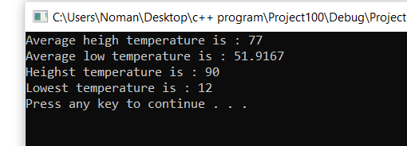**output**

**Question #8**

#include<iostream>

using namespace std;

int dayNumber(int day, int month, int year)

{

static int t[] = { 0, 3, 2, 5, 0, 3, 5, 1, 4, 6, 2, 4 };

year = month < 3;

return (year + year / 4 - year / 100 + year / 400 + t[month - 1] + day) % 7;

}

string MonthName(int monthNumber)

{

string months[] = { "January", "February", "March", "April", "May", "June","July", "August", "September","October", "November", "December" };

return (months[monthNumber]);

}

int numberOfDays(int monthNumber, int year)

{

// January

if (monthNumber == 0)

return (31);

// February

if (monthNumber == 1)

{

// If the year is leap then February has// 29 days

if (year % 400 == 0 ||

(year % 4 == 0 && year % 100 != 0))

return (29);

else

return (28);

}

// March

if (monthNumber == 2)

return (31);

// April

if (monthNumber == 3)

return (30);

// May

if (monthNumber == 4)

return (31);

// June

if (monthNumber == 5)

return (30);

// July

if (monthNumber == 6)

return (31);

// August

if (monthNumber == 7)

return (31);

// September

if (monthNumber == 8)

return (30);

// October

if (monthNumber == 9)

return (31);

// November

if (monthNumber == 10)

return (30);

// December

if (monthNumber == 11)

return (31);

}

void Calendar(int year)

{

cout << year;

int days;

int current = dayNumber(1, 1, year);

for (int i = 0; i < 12; i++)

{

days = numberOfDays(i, year);

MonthName(i).c_str();

cout << "\n\nThu Fri Sat Sun Mon Tue Wed" << endl;

int k;

for (k = 0; k < current; k++)

cout << " ";

for (int j = 1; j <= days; j++)

{

if (j < 10)

cout << j << " ";

else

cout << j << " ";

if (++k > 6)

{

k = 0;

cout << endl;

}

}

if (k)

cout << endl;

current = k;

}

return;

}

int main()

{

int year = 2022;

Calendar(year);

system("pause");

return (0);

}

**Output**

